**ISTE-444 Project 1: Application Performance Monitoring**

**D**ishant Mishra, Winston Chang

**Introduction**

Given programs that utilizes various resources from the computer, we were writing a script that would analyze and profile the amount of resources being used on the computer while these programs were running as time goes on.

**Process Level Metrics**

**Describe what the CPU utilization plot shows in 2-3 sentences.**

APM1 had the largest usage of CPU, later stabling as time goes on. The other APMs slowly increased CPU usage over time.

**Describe what the memory utilization plot shows in 2-3 sentences.**

Most of the APMs utilized memory well, except for APM 6, which you can visibly see the memory usage going up and not dropping over time.

**System Level Metrics**

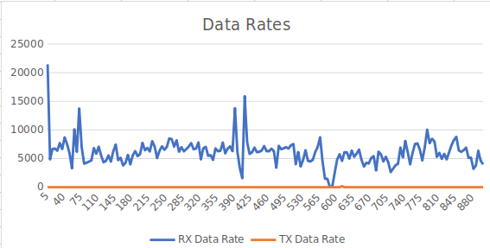

**Describe what the network bandwidth utilization plot shows in 2-3 sentences.**

While data was being transmitted at a stable rate, they were definitely not being received at the same rate. The plot displays the sporadic rate of receiving data.

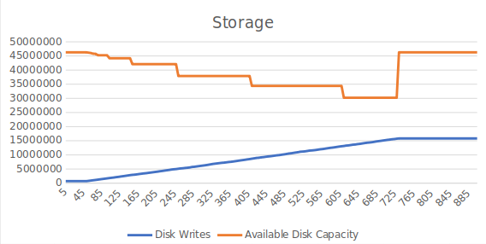

**Describe what the hard disk access rates plot shows in 1-2 sentences.**

As time goes on, the amount of disk writes being performed increases.

**Describe what the hard disk utilization plot shows in 1-2 sentences.**

As expected, the disk capacity decreases as data was being written to the disk.

**Summary and Lessons Learned**

Write 3-4 sentences that describes whether or not the VM you used had enough computing resources (CPU, memory, network capacity, and disk) to handle the mix of application processes that were running and what lessons you learned while working as a team on this project.